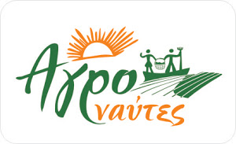
AGRONAYTES Consumers and Farmers Network
CSA – Community Supported Agriculture groups in Athens, Greece
http://agronaftes.blogspot.com/

The intensifying of agriculture production in combination with the massive urbanization has substituted the relation of producer-consumer with an exceptionally complicated system. Whoever profits of this system begins to strike strong concerns in front of the obvious henceforth disadvantages of price and quality of foods that reaches in consumers’ hands in addition to all not ecological and energy and food wasting practices of today’s system. Agronaftes group participating in the solidarity trade stop parasitic trading actions with obvious profit for the consumer. Simultaneously we build the essential trust based in close contact with the producers which guarantee the food quality without certification organizations which they can not substitute the human relations of confidence.

The group Agronaftes has formed a network of farmers-consumers that aims to develop a network of producers of agricultural products and foods, with the immediate connection to the consumers. The Agronaftes contribute in volunteering basis to serve the farmers and the final consumers. Important aspects is also that we try to promote with our actions high organic food quality, self-sufficiency, lower waste of foods and energy, as well as the social organisation in local neighbourhood level. We aim with simplicity and enjoyment in our implemented actions, as ‘if it is not fun, it is not sustainable’.

Agronaftes have four types of activities:

1. Provision of agricultural products from selected producers of Peloponnese (southern Greece) with minimum quantity completion order of the available products. All products come from small scale independent producers whom we know and trust.

2. Management and cultivate a collective garden (called Agronafto-kipos) which constitutes a example for sustainable garden that provides clean food. It is located at Asopos village near Monemvasia, Peloponnese and it welcomes volunteers and new cultivators that they wish to shared knowledge and efforts.

3. Initiative of CSA groups operating in weekly subscribing base in the Athens area, mainly for vegetables from local organic producers, but also fruits and other foods..

4. Presentations and promotion of the CSA model to new groups, producers and wide public. We support the CSA model and help in the formation of new groups by giving speeches, presentations, participating in festivals and congresses. Support comes in many ways by sharing existed knowledge for consumers, groups’ coordinators and producers to how understand and adjust in the CSA models demands

Note 1: This report focuses on the CSA activities of Agronaftes and mainly aims in the description of group dynamics developed emitting theoretical descriptions about CSA definitions. They are attended by Thomas Anemos, where the other activities described in #1 and #2 above are attended by Vangelis Vlahakis.
Notice 2: In Greek language we have named CSA as KOSAP (as it has sounding affiliation with ‘Coop’).

Historical elements of the Agronaftes KOSAP groups:

In 2010-11 the Agronaftes initiative began with the voluntary effort of two members of the Eco group OikoHoria which is promoting and supporting the intentional community movement in Greece. The creation of the CSA project KOSAP of Agronaftes was first time presented in the members of the OikoHoria group in November 2010 and second time in a Ecological festival in Marathonas on May 2011, where we come in contact with our first interested producer. More presentations to other groups, festivals and congresses were followed.
In 2011-12 began the first three teams in Halandri, Vrilisia, Pagrati in Athens area with 15-30 baskets of vegetables per group supplied by one organic producer.
In 2012-13 the teams became four in Halandri, Ag. Paraskevi, Pagrati and Thisio with 15-35 baskets of vegetables per group and we changed the first producer, added two new producers and occasional other two organic fruits producers.
In 2013-14 the groups were multiplied in many other neighbourhoods (look below) mainly due to initiative of one of our producers to accept and organise smaller in number (5 baskets) deliveries in more locations.
This year 2014-15 we continue with the four large teams mentioned above and the many smaller ones in the districts of Kifisia, Amarousio, Illioupolis, Argiroupolis, Alimo, Faliro, Kipseli, Exarhia, Gizi, supplied by the two producers. We reported big help coming from one producer himself who has embraced the initiative and support it himself bringing also in his customers and delivering as minimum 5 baskets in close neighbourhoods rather than the 20 baskets minimum which was the initially number required.
The basket continues to include more than 8 kilos organic seasonal vegetables. The vegetables are delivered in bags which are easier to transport, carry and required no other action on delivery since that the consumer collects a new full bag and returns the empty bag. The compensation is 10 euro, payable upon delivery for acquaintance with new consumers. Strong objective this year is to introduce the advance monthly payment of 40 euro for 4 baskets, ensuring that missed baskets can count towards next month subscription. Advance payment will be made straight to the producer in order to avoided monetary exchange on the streets which may have possible future legal restrictions; so in this case the producer carrier only delivers and is not selling on the streets.

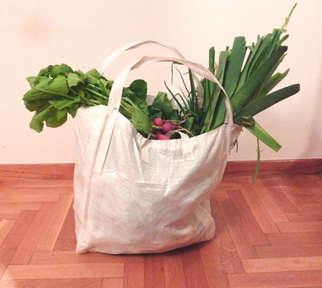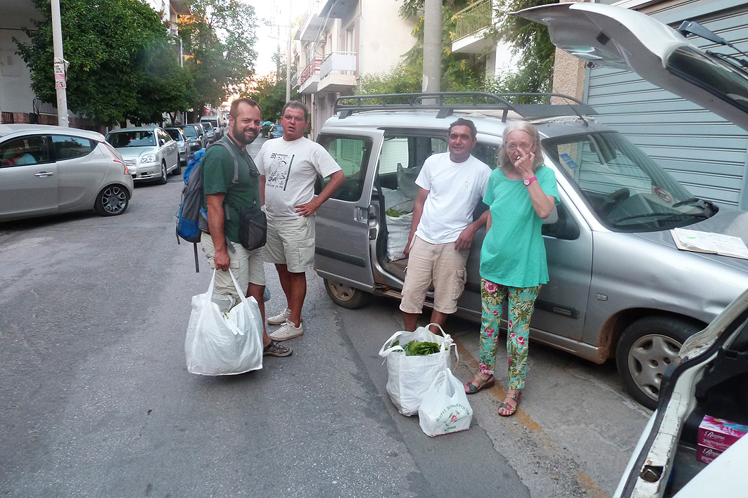

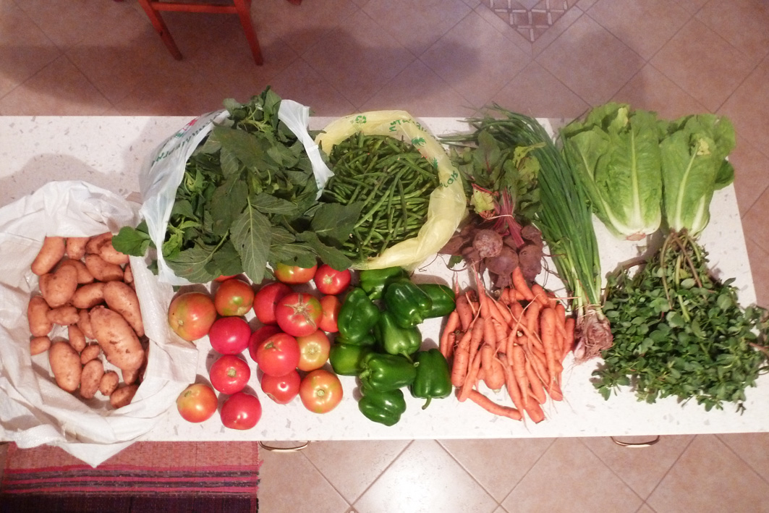
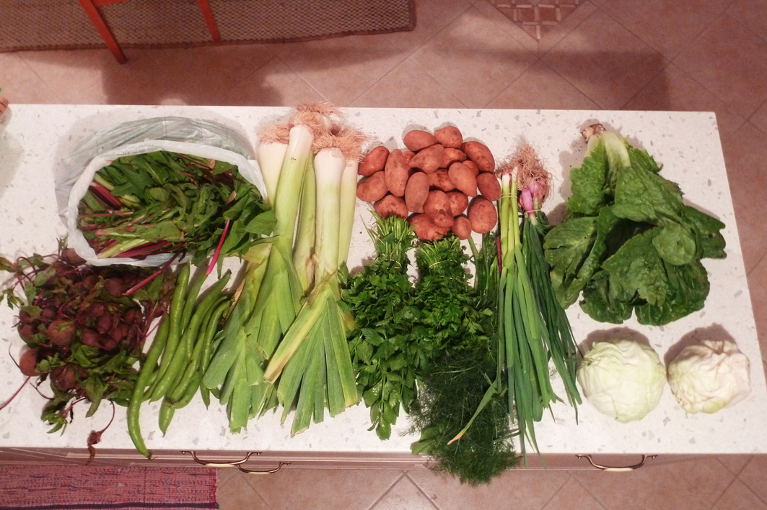

Photos of the vegetable bag, its contents and a delivery moment.

Today, after three years of operation of the KOSAP groups, we can say that the initiative is increasing and embraced by more consumers. The groups function independently operating autonomously by the volunteers of each group. Agronaftes keep contacts, pass new signing up consumers thought the web blog to the groups, and invite all to affiliated public activities.
We saw two models developing and coming to existence:
(a). Bigger member groups of 20-30 members with active coordinator from the consumers, which model encourages and other type side orders.
(b). Smaller member groups with active coordinator from the producer side, which encourages larger distribution, more convenient for new members to join and offers more support for new groups to start.

We see smaller interest and strong reluctance from new producers to join the KOSAP models. Also we would like to see small beginner producers to be supported by CSA groups and be a model for others. These are direct objective for further evolution. We slowly understand the dynamics of CSA growth in Greece and how it is determined by different involving factors and sides of interest. Some mentioned here are: the consumers’ dietary and purchasing habits, the organizing willingness of the volunteer coordinators of the groups, the producers cultivating and distributing practices, the perception of average dietary habits for sufficient balanced vegetables basket, the groups coordination ability to choose the location for convenient deliveries and attracting new participants, and last but not least, what is good organic product offers for the consumers. Also the dynamics of growth determined by the personal acquaintances and relationships of building confidence that are well needed. This fact we also try to promote and support with visits and annual celebrations at the producers’ farms. In June 2013 and in June 2014 we made the 1st and 2d open gathering celebrations for all groups and interested individuals and hope to continue next year. We would like also to see groups in other large cities beside Athens area being developed in the future.
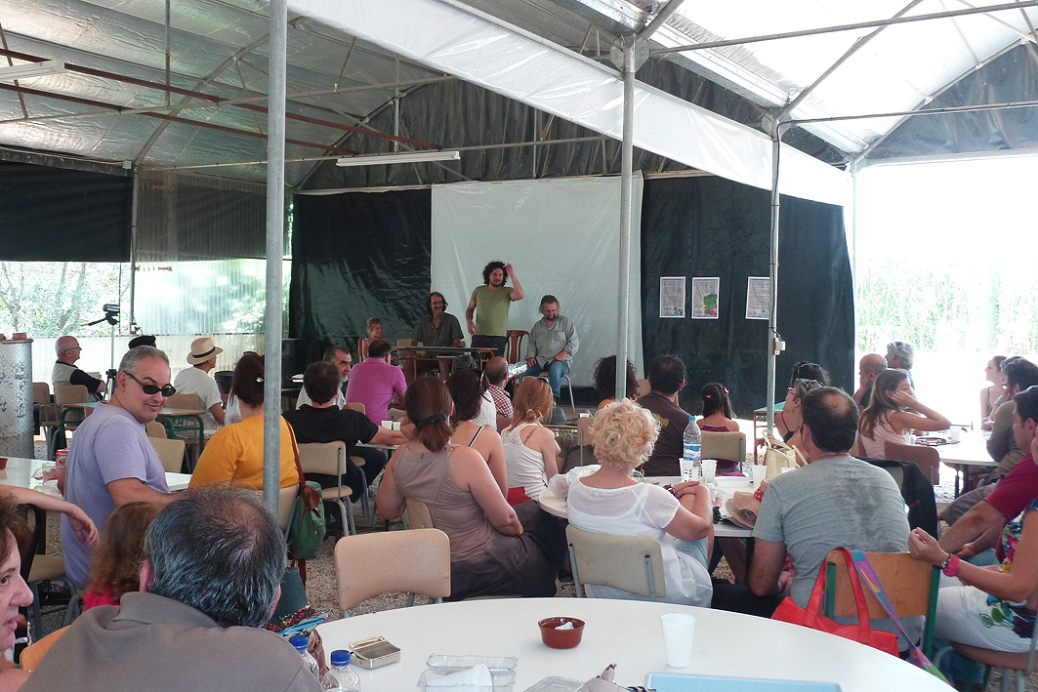
Photo from first annual gathering June 2013

Fruits and other products:. We have some experience with fruits, especially with oranges distributed with minimum filled orders. We have also one oranges producer who distributes also other fruits from third producers in order to be active all year around and delivers at the same time with the vegetables bags. The group in Pagrati also orders other products in bulk quantities (beans, flour, oil etc). Members of the group in Halandri they have been inspired and contributing in organizing successfully mass distributions of foods without intermediaries (this action is called ‘Mazi na ta Fame’).

Total assessments of the current activities of the KOSAP groups.
Today one of our producer delivers daily 50-70 baskets, five days a week, which counts to 300 baskets per week, with total turn over 3 tons of organic vegetables per week. Also he supplies by request eggs, cheese, tomato sauce, pork and lamp meat when are available. Our second producer delivers about 50 baskets per week, counting for total turn over half ton of organic vegetables per week. He also supplies by request yoghurt and flour. These activities seem to nourish about 350 families (or 1500 individuals).

Publications: Articles about the Agronaftes have been published twice in newspapers, listed in other web pages and we have given interviews in the radio. We have been included in one university research thesis and we have some contacts with university professors who do academic research in the area of alternative methods of food production.

Closing, we are expressing our gratitude for being invited in the GROWL proceedings.
On behalf of the Argonaftes,
Thomas Anemos
email thomas_anemos@yahoo.com
September 2014

