GROWL INTERNATIONAL COURSE “SOLIDARITY & COOPERATIVE ECONOMY”
1-6 OCTOBER 2014, THESSALONIKI, GREECE

PRACTICAL READER

Dear friends,

We would like to welcome you to the realization of the GROWL international course on “Solidarity and Cooperative Economy”.

This intensive 6 day course is structured in such a way in order to tackle various theoretical, practical and political issues of degrowth and solidarity economy. The course includes the two GROWL core modules (Degrowth lite and TTT- train the trainers) plus a combination of lectures, discussions, workshops and showcases on various aspects of solidarity economy.

The course will be realized in various locations in Thessaloniki, Greece. Following there are some practical information on how to get to Thessaloniki, the different venues and what you need to bring along for your stay and your inputs during the course.

How to get to the hostel:

The Hostel where we will stay on Wednesday and Thursday is named RentRooms and is located in Konstantinou Melenikou 9 (map).

From Thessaloniki Airport please take BUS No.78 towards K.T.E.L. and get off at stop H.A.N.TH. then walk about 10 minutes as indicated by the blue dots in the map you find below.

From the train station please take bus No.10 or No.11 and get off at the bus stop Kamara which is indicated by the red arrow in the map. You will get to the hostel in 5 minutes walk.
You can find info on bus routes here.

On Wednesday, arrival day, we will meet at the hostel the latest at 19.00 where we will have a welcoming session and dinner.

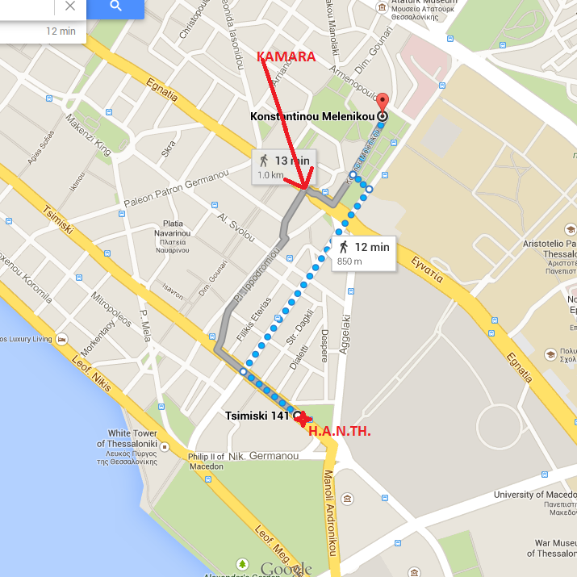

The venue for Thursday is Oikopolis social center (Ptolemaion 29/A, 5th floor) where we will have sessions until 18.00 and lunch. See the map here.

On Thursday at 18.15 we will depart (bus 14) for the Aristotelion University of Thessaloniki (see the map here) where we will have the open public event for the Greek audience.

Dinner on Thursday night will be served at Steki Metanaston which is located in Ermou 23 (see the map here).

Friday morning session will be hosted at PERKA farm (map), where we will also have lunch. We will go there by public transport (bus 38).

Friday afternoon session will be hosted in VIOME reclaimed factory (map) where we will go by bus. After that we will depart by bus and cars for Tagarades farm (map), where we will spend the rest of the seminar.

In Tagarades farm we will stay in shelters (no beds- please bring under-mats). We will be able to have a more self-managed kitchen and we will all help with cleaning our dishes.

On Monday we will depart from Tagarades for Thessaloniki airport by car.

N.B.: please keep in mind that you will need to bring your sleeping mattresses, under-mats, towels and personal hygiene stuff for your stay in Tagarades farm. It might be chilly in Tagarades so please bring warm and comfortable clothes. In case of good weather those wishing to camp with their tents in the beautiful surrounding of the farm are more than welcome to do so.

EMERGENCY NUMBERS:
RentRooms Hostel: +30 2310 204080
Michalis Theodoropoulos: +30 6977 705226, mtheodoropoulos@gmail.com
Pavlina Lazaridou: +30 6945 532778, pavlina.lazaridou@antigone.gr
Domenico Giannoccaro: +30 6972 151479

About the city:
Thessaloniki (Θεσσαλονίκη) is the second-largest city in Greece and the capital of the periphery of Central Macedonia. Furthermore, it is Greece's second major economic, industrial, commercial and political centre and a major transportation hub for the rest of Southeastern Europe; its commercial port is also of great importance for Greece and the Southeastern European hinterland.

This city has a strategically relevant position thanks to its proximity to the Balkan region (Sofia, Skopje and Tirana). Thessaloniki constitutes an important gate from Europe to Middle East as well (Istanbul is distant about 600 km).
Due to its geographic location, Thessaloniki has witnessed a constantly and important flux of migrations. Since the exchanges of population between Greece and Turkey in the early 20th century, to the latest exodus of populations from conflict areas like former Yugoslavia and from some African and Asian countries, the city has been the final or the temporary destination of many people of different nationalities and cultural backgrounds.
It is worth to be mentioned as well, that the presence of the Mediterranean influences the lifestyle of the city.
One of the particularities of the city is its intercultural character. There is a mix of cultures that makes Thessaloniki different from the rest of Greece. It is a city with frenetic life during the day thanks to its markets, crowded squares and seaside terraces, and during the night, with a lot of bars, taverns and music live concerts.
You can feel an atmosphere completely different from the typical capital cities in Europe. Thessaloniki has a modern character, also keeping its Mediterranean roots and ancient origins.
Thessaloniki is also famous for its universities. It hosts Aristotle University, the biggest university of the country and of all the Balkans. The city has one of the biggest student population in Europe indeed!
The city centre is small according to the population. It allows the visitors to walk easily to reach the most important and interesting places. The old town, called Ano Poli, is on the top of the hill of Thessaloniki. From Ano Poli it is possible to enjoy sights of the whole city and to discover the ancient structure of Thessaloniki. This neighborhood has preserved its original architecture. After the big fire of 1917 which destroyed almost all the city except of Ano Poli, in few decades Thessaloniki has changed its face, following the trends of industrialization and modernization.

